Presentation

Create a WP plugin that allows the customer to filter content on the frontend.
General recommendation: Code by thinking about the plugin performance because this is something critical in WordPress in general and more important on plugins that potentially will handle a large amount of content.
Competitor plugins: https://drive.google.com/drive/u/0/folders/139igsuRdWmeYBUsNpe9CwTLBKYv3LwPc

How does the plugin work?

The user creates a filter set with custom filters. To load the filters on the frontend, there are 3 options:
- Force the display of some part of the website, for example post categories > Select 2 categories
- Use a shortcode
- Use a PHP snippet

A preview of the filters is always displayed on the right part.

Customer issue we need to solve

- Current filter extensions have tons of options but are very complicated to set up
- I’s complicated to display the filters on the frontend because using Shortcode some WordPress views are not necessary accessible depending on the theme, like a post category
- Need SEO settings to avoid problems with search engines (filter generates tons of URLs)
- Need to work with WordPress posts (Gutenberg), custom posts, WooCommerce, Elementor posts and DIVI (no widget yet, just detect post modules)

Extension features

Filter set edition and features

Filter set management (filter set edition view with tabs for configuration)
Tab1 = Filter set
- Filter set title: input text
- “Select the post type to filter” = posts, pages, products, custom posts (similar to “filter everything pro” plugin)
Help text = “What is the type of content you want to filter”
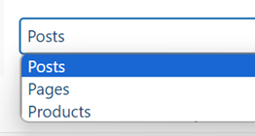
- “Apply filter set to” (similar to “filter everything pro” plugin)
Help text = “Define where the filter set will be loaded on your WordPress frontend. Alternatively, you can use shortcode or PHP snippet”
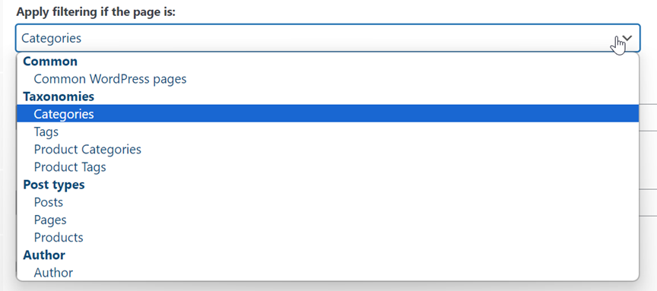

Tab2 = Filter fields
- Add filter button + filter selection like in “filter everything pro” plugin
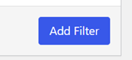
- Add a search field to this dropdown list
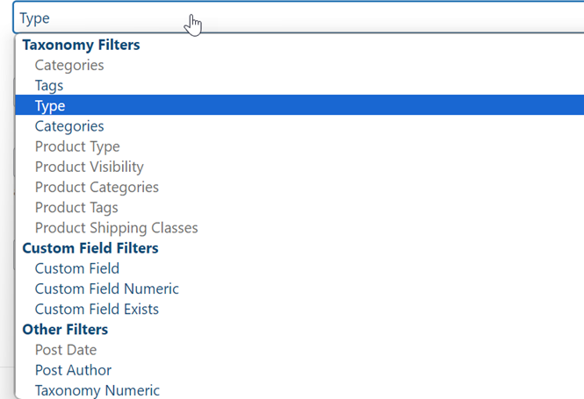

- Filter title: input text
Help text = “The filter name displayed on the frontend”
- Filter help tooltip: input text
Help text = “The filter help tooltip displayed on the frontend”
- Filter control: dropdown list
Help text = “Type of control you want to user for the filter”
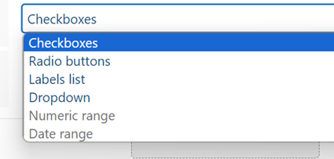

Filter position: Column left / Column right
Help text = “Select the filter position, if only the left column is selected, it’ll be 100% width”

Tab3 = Settings
- Display empty terms: On/Off toggle
Help text = “Display the filter terms results, event if no content is found, ex. An empty category”
- Show result count: On/Off toggle
Help text = “Display the count of elements for each term”
- Apply button: On/Off toggle
Help text = “Use an apply button to validate the filtering”
- Apply button text
Help text = “Text of the apply button, default is: APPLY FILTERS”
- Reset button: On/Off toggle
Help text = “Use a reset button to empty all the filtering”
- Reset button text
Help text = “Text of the apply button, default is: APPLY FILTERS”
- Search field placeholder
Help text = “Text placeholder displayed inside the search field”
- Auto-apply search: On/Off toggle
Help text = “When the user adds some text in the search field, auto-apply search”
- Use AJAX dynamic filtering: On/Off toggle
Help text = “When the user selects some filters, auto-apply filtering”

Tab4 = Design
- Filter set width: Desktop / Tablet / Mobile
Help text = “Force the layout to be 50/50 or 100% width, depending on the device”

- Submit button background
Help text = “Submit button background color”
- Submit font color
Help text = “Submit button font color”
- Submit font size
Help text = “Submit button font size”
- Submit border radius
Help text = “Submit button border radius”
- Reset button background
Help text = “Reset button background color”
- Reset font color
Help text = “Reset button font color”
- Reset font size
Help text = “Reset button font size”
- Reset border radius
Help text = “Reset button border radius”

WordPress plugin admin navigation
- WP Ultra Filter
  - Filter sets
  - Settings

Integrations

- WP Blog views
- WooCommerce products
- Page builder post widgets for Elementor and DIVI

Installation
- Add 2 default filters by default that are in draft state: one for blog post views, one for WooCommerce categories product listing

Design and UX
- We’ll provide Figma UX design

Global settings
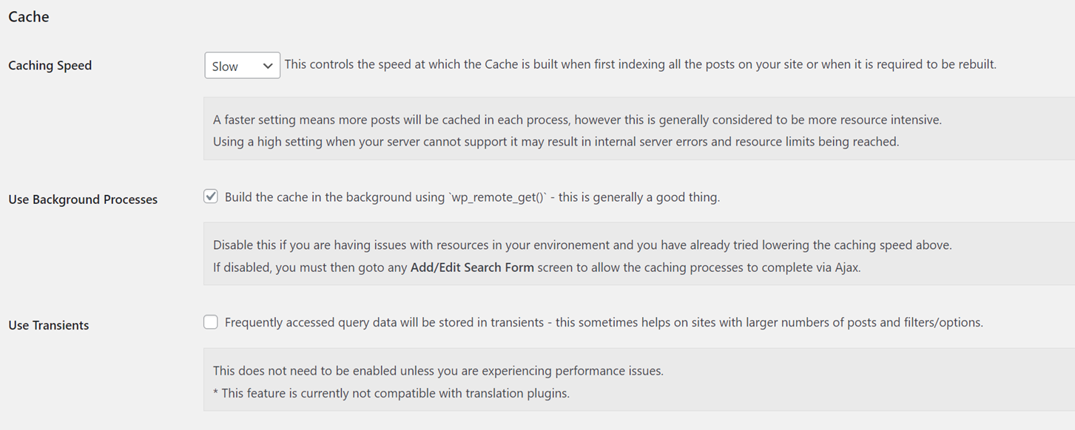

Competitors examples

https://codecanyon.net/item/filter-everything-wordpress-woocommerce-filter/31634508
https://wordpress.org/plugins/woo-product-filter/
https://fr.wordpress.org/plugins/search-filter/
https://wordpress.org/plugins/woo-product-filter/
https://wpgridbuilder.com/ >> I didn’t manage to make it work?

Extension UX

Always keep a preview of the filter displayed

Future version features
- Filter other page builders widget: Visual Composer, WP Bakery, Brizy, SiteOrigin Page Builder, Thrive Architect, Beaver Builder
- Create filter groups
- Search result container or ID
- SEO Title, H1, meta description for each filter set
- Floating position for the filters

